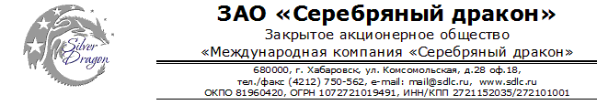

Шпиндельные двигатели Haina
Permanent Torque Spindle
0.3kw spindle motor
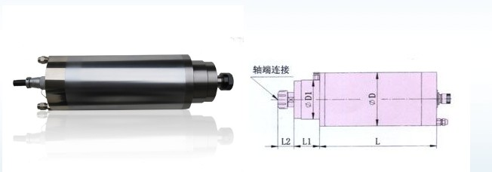
0.3 kw Spindle Motor

Brand name: Haina
Spindle type: HNZ-48D/0.3
Function: used in wood carving machine
Rev(r/min): 20000rpm-60000rpm
Power(kw): 0.3
Voltage(v): 75
Current(A): 2.5
Frequency(HZ):333-1000
Cool: cooled by water
Bearing type: 2*NSK7001CP4 1*SW7001CP4
Lubricate: grease
Repair time: bearing(half year), spindle(one year)
Collet(mm): ER8
Diameter(mm): 48
D1:42MM
Length:119mm L1:6mm L2:25mm
0.8kw Spindle Motor
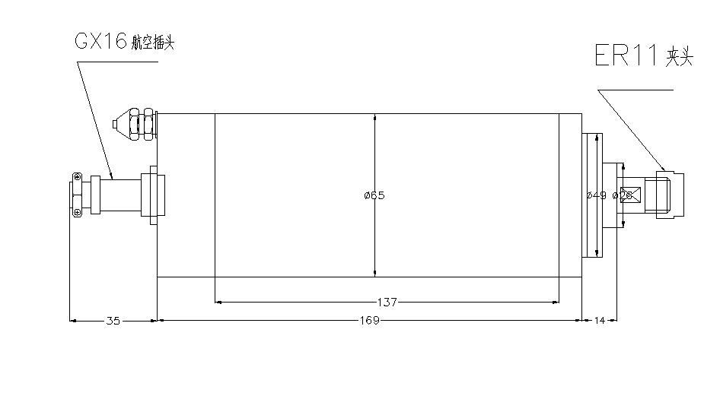
0.8 kw Spindle Motor

Brand name: Haina
Spindle type: HNZ-65D/0.8
Function: used in wood carving machine
Rev(r/min): 24000
Power(kw): 0.8
Voltage(v): 220
Current(A): 5.0
Frequency(HZ): 400
Cool: cooled by water
Bearing type: 1*7002CP4 1*7002CP4
Lubricate: grease
Repair time: bearing(half year), spindle(one year)
Weight(kg): 3.1
Collet(mm): ER11
Diameter(mm): 65
EXW：USD114

0.8kw-A Spindle Motor 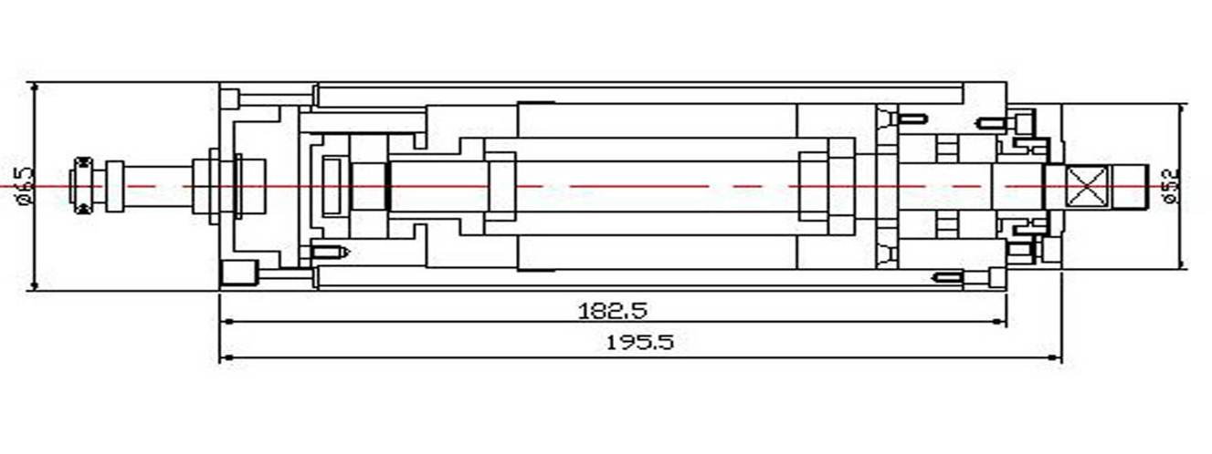
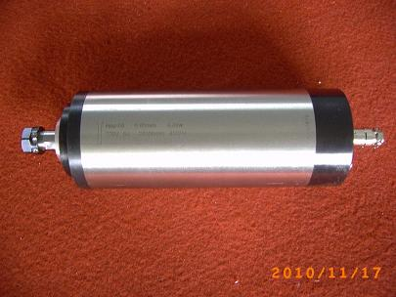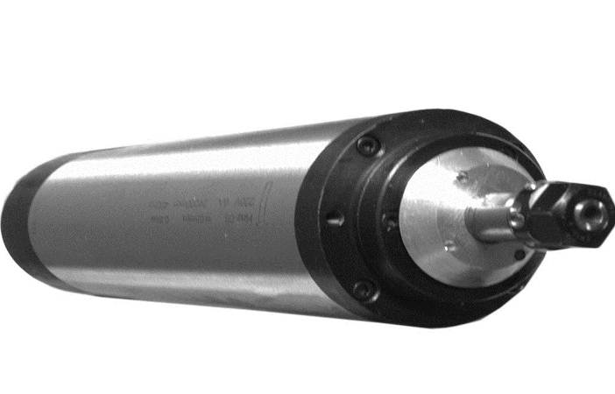
0.8kw-A Spindle Motor

Spindle type: HNZ-65D/0.8A
Brand name: Haina
Function: used in wood carving
Rev(r/min): 24000
Power(kw): 0.8
Voltage(v): 220
Current(A): 5.0
Frequency(HZ): 400
Cool: cooled by water
Bearing type: 2*7002CP4 1*7002CP4
Lubricate: grease
Repair time: bearing(half year), spindle(one year)
Weight(kg): 4
Collet(mm): ER11
Diameter(mm): 65
EXW：USD139

1.5kw Spindle Motor
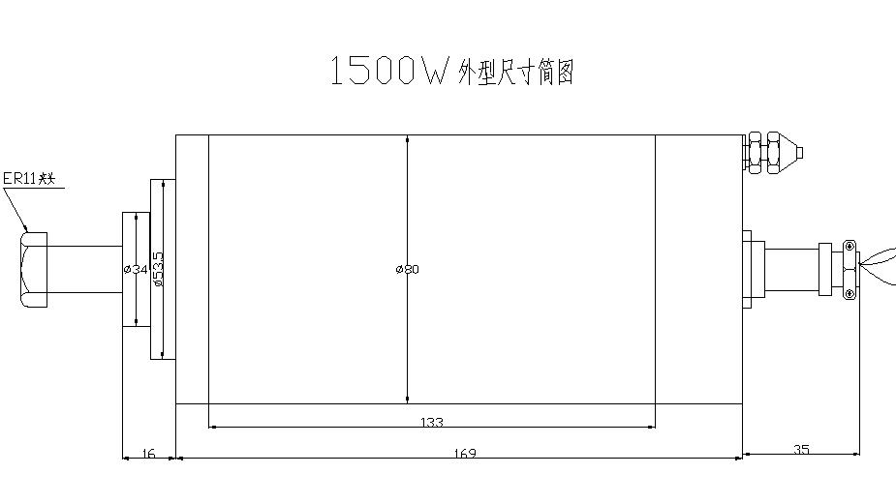
1.5kw Spindle Motor

Brand name: Haina
Spindle type: HNZ-80D/1.5
Function: used in wood carving , drilling , engraving and milling machinery

Rev(r/min): 24000
Power(kw): 1.5
Voltage(v): 220
Current(A): 6.5
Frequency(HZ): 400
Cool: cooled by water
Bearing type: 1*7002CP4
1*7002CP4
Lubricate: grease
Repair time: bearing(half year), spindle(one year)
Weight(kg): 4.5
Collet(mm): ER11
Diameter(mm): 80

1.5kw-A Spindle Motor
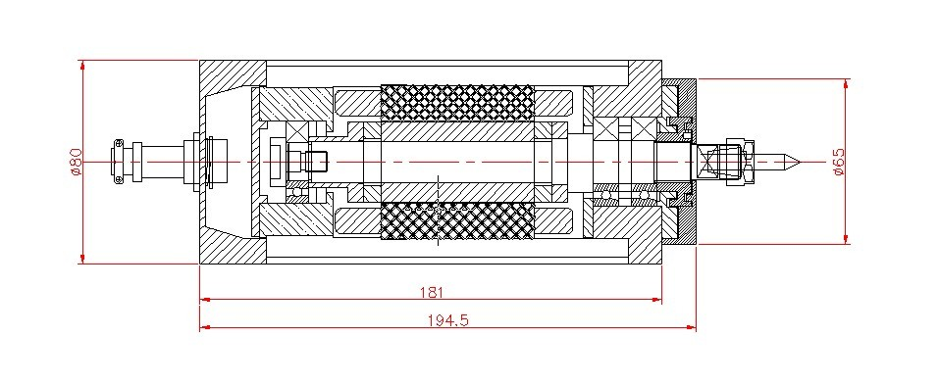
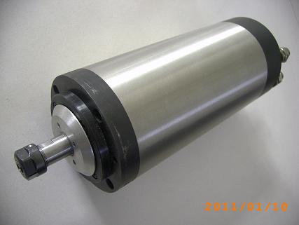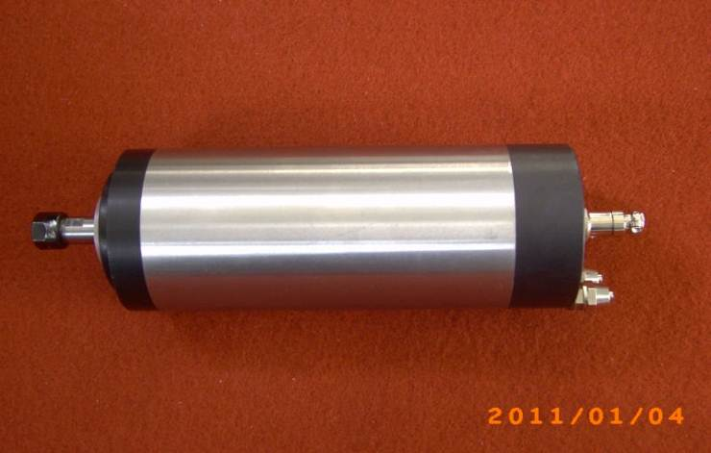
1.5kw-A Spindle Motor
Spindle type: HNZ-80D/1.5A
Brand name: Haina
Function: used in wood carving machine
Rev(r/min): 24000
Power(kw): 1.5
Voltage(v): 220
Current(A): 6.5
Frequency(HZ): 400
Cool: cooled by water
Bearing type: 2*7003CP4 1*7002CP4
Lubricate: grease
Repair time: bearing(half year), spindle(one year)
Weight(kg): 6.0
Collet(mm): ER11
Diameter(mm): 80
EXW：USD139
2.2kw-A Spindle Motor
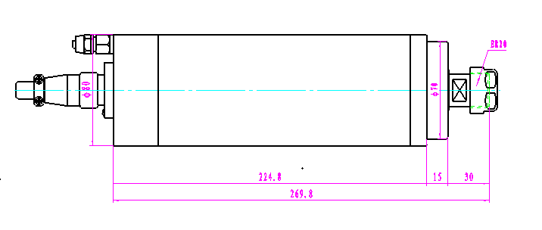
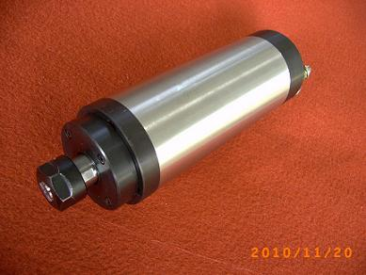
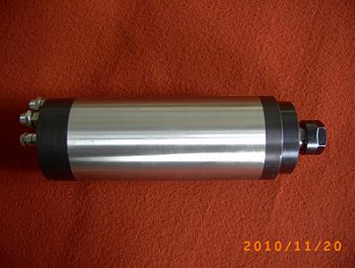
2.2kw Spindle Motor
Spindle type: HNZ-80D/2.2A
Brand name: Haina
Function: used in wood carving machine
Rev(r/min): 24000
Power(kw): 2.2
Voltage(v): 220
Current(A): 8
Frequency(HZ): 400
Cool: cooled by water
Bearing type: 2*7005CP4 2*7002CP4
Lubricate: grease
Repair time: bearing(half year), spindle(one year)
Weight(kg): 7
Collet(mm): ER20
Diameter(mm): 80
EXW：USD245

2.2kw-B Spindle Motor
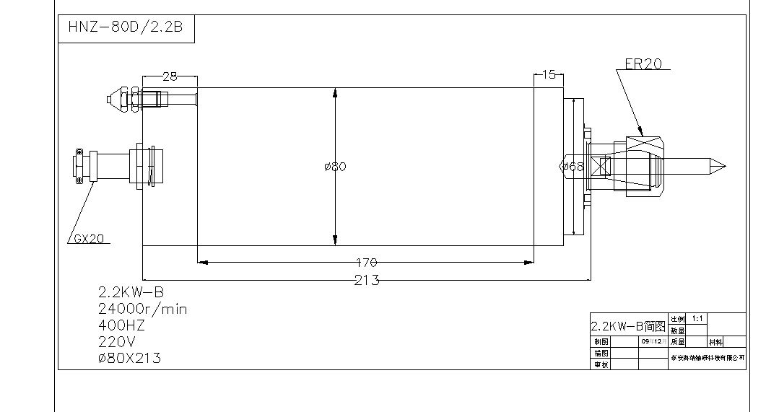

Spindle type: HNZ-80D/2.2B
Brand name: Haina
Function: used in wood carving machine
Rev(r/min): 24000
Power(kw): 2.2
Voltage(v): 220
Current(A): 8
Frequency(HZ): 400
Cool: cooled by water
Bearing type: 2*7005CP4 1*7002CP4
Lubricate: grease
Repair time: bearing(half year), spindle(one year)
Weight(kg): 7
Collet(mm): ER20
Diameter(mm): 80
EXW：USD228

3.0 kw-220v Spindle Motor
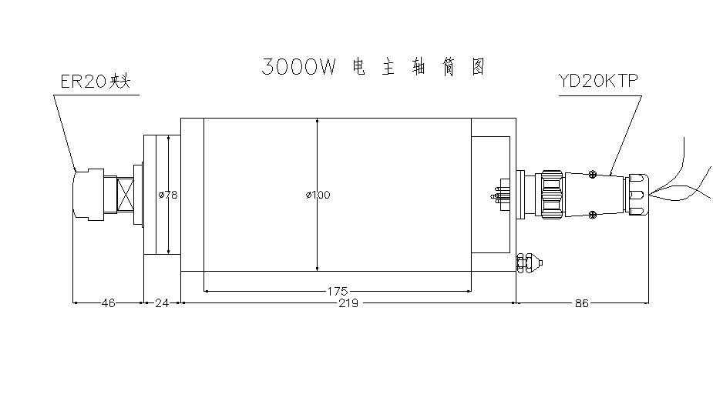
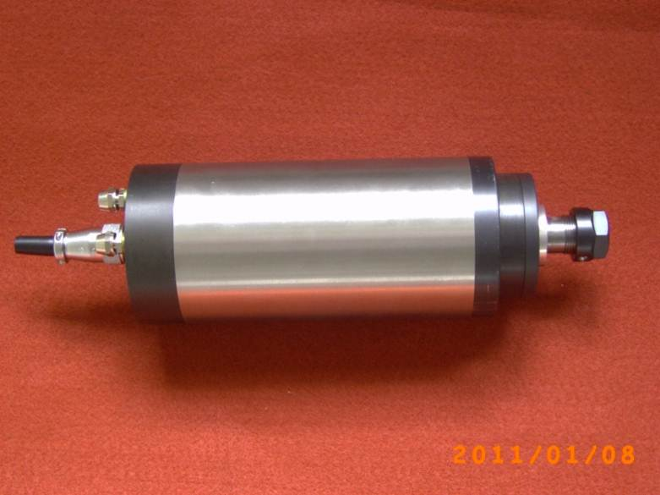
3.0kw-220v Spindle Motor

Brand name: Haina
Spindle type: HNZ-100D/3.0-220
Function: used in wood carving machine
Rev(r/min): 24000
Power(kw): 3.0
Voltage(v): 220
Current(A):12
Frequency(HZ): 400
Cool: cooled by water
Bearing type: 2*7005CP4 1*7003CP4
Lubricate: grease
Repair time: bearing(half year), spindle(one year)
Weight(kg): 12
Collet(mm): ER20
Diameter(mm): 100
EXW：USD257
3.0 kw-380v Spindle Motor

3.0kw-380v Spindle Motor
Brand name: Haina
Spindle type: HNZ-100D/3.0-380
Function: used in wood carving machine
Rev(r/min): 24000
Power(kw): 3.0
Voltage(v): 380
Current(A): 10
Frequency(HZ): 400
Cool: cooled by water
Bearing type: 2*7005CP4 1*7003CP4
Lubricate: grease
Repair time: bearing(half year), spindle(one year)
Weight(kg): 12
Collet(mm): ER20
Diameter(mm): 100
EXW：USD257

4.5kw-110D Spindle Motor
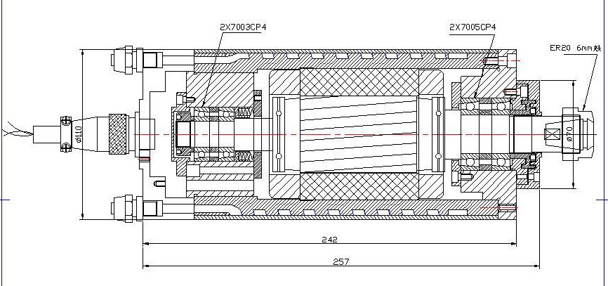4.5kw-110D Spindle Motor
Brand name: Haina
Spindle type: HNZ-110D/4.5
Function: used in wooden carving , drilling , engraving and milling machinery
Rev(r/min): 24000
Power(kw): 4.5
Voltage(v):380
Current(A): 10
Frequency(HZ): 400
Cool: cooled by water
Bearing type: 2*7005CP4 2*7003CP4
Lubricate: grease
Repair time: bearing(half year), spindle(one year)
Weight(kg): 16
Collet(mm): ER25
Diameter(mm):110
EXW：USD455
4.5kw-125D Spindle Motor
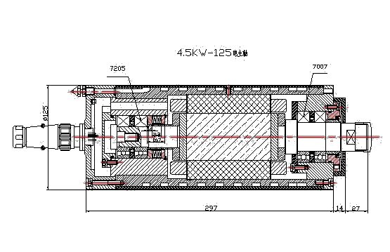
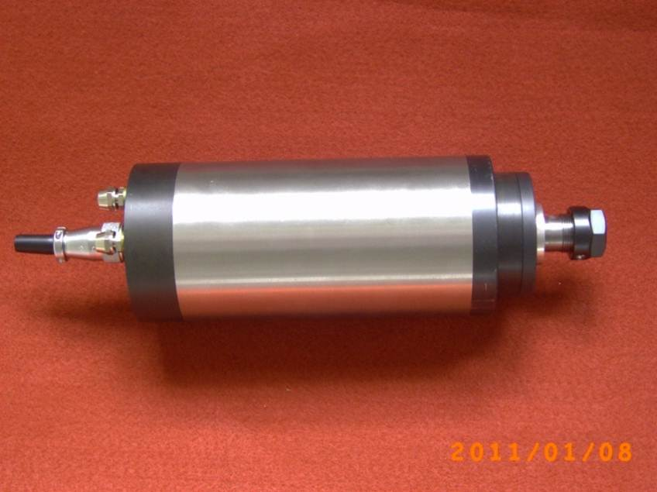

4.5kw-125D Spindle Motor

Brand name: Haina
Spindle type: HNZ-125D/4.5
Function: used in wooden carving , drilling , engraving and milling machinery
Rev(r/min): 24000
Power(kw): 4.5
Voltage(v):380
Current(A): 10
Frequency(HZ): 400
Cool: cooled by water
Bearing type: 2*7007CP4 2*7205CP4
Lubricate: grease
Repair time: bearing(half year), spindle(one year)
Weight(kg): 16
Collet(mm): ER25
Diameter(mm):125
EXW：USD535

Stone engraving machines

3.5kw spindle motor for stone engraving
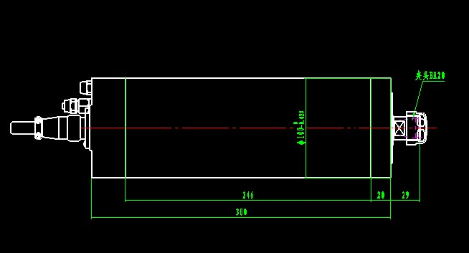
3.5kw Spindle Motor：
Brand name: Haina
Spindle type: HNZ-3.5
Function: used in wood carving machine and engraving
Rev(r/min): 18000-24000
Power(kw): 3.5
Voltage(v): 380
Current(A): 7.4
Frequency(HZ): 300
Torque：1.96Nm
Cool: cooled by water
Lubricate: grease
Bearing type: 2*7007CP4 2*7002CP4
Repair time: bearing(half year), spindle(one year)
Weight（kg）：9
Collet(mm): ER20
Diameter (mm): 100
EXW price: USD 610

4.5kw spindle motor for stone engraving
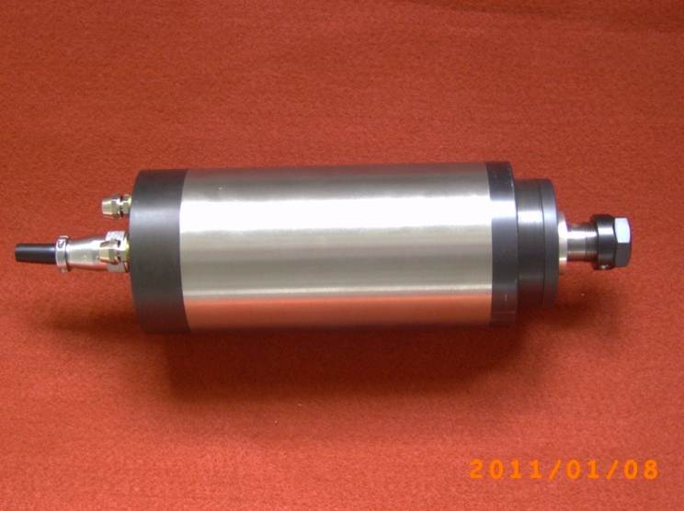
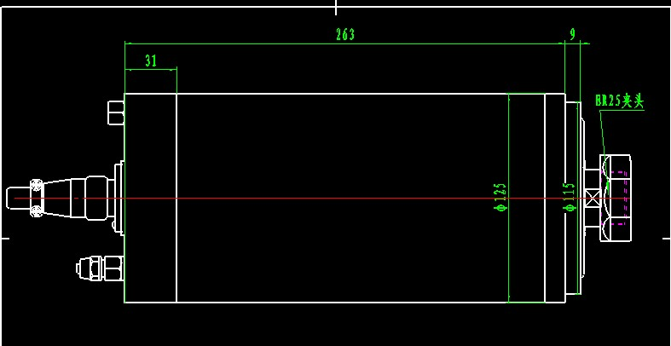
4.5kw Spindle Motor：
Brand name: Haina
Spindle type: HNZ-4.5
Function: used in stone carving machine and engraving
Rev(r/min): 18000-24000
Power(kw): 4.5
Voltage(v): 380
Current(A): 9.0
Frequency(HZ): 300
Torque：2.38Nm
Cool: cooled by water
Lubricate: grease
Bearing type: 2*7008CP4 2*7002CP4
Repair time: bearing(half year), spindle(one year)
Weight（kg）：11.5
Collet(mm): ER25
Diameter (mm): 125
EXW price :USD 691

Permanent Power Spindle
1.2kw Spindle Motor
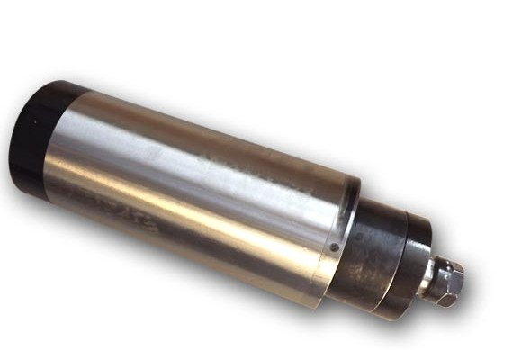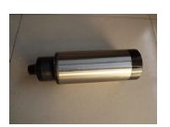

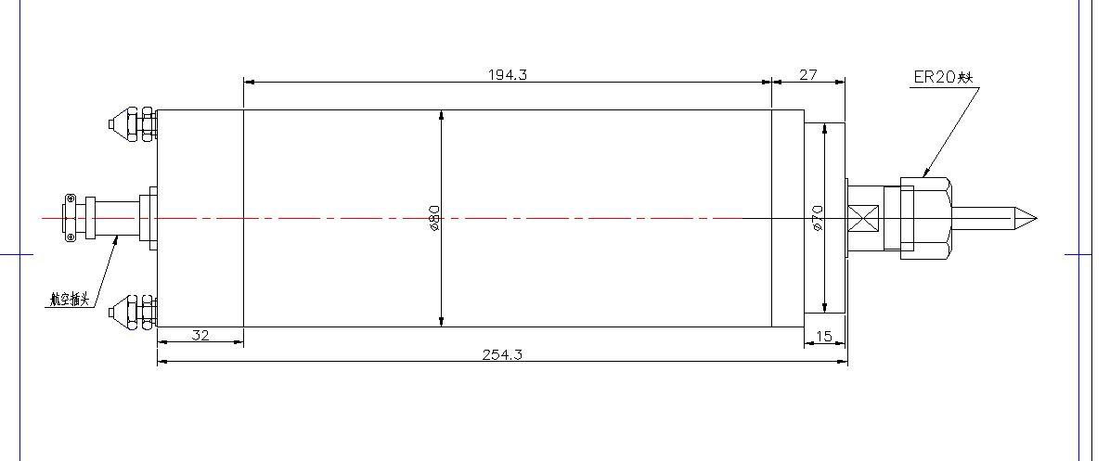
1.2kw Spindle Motor (Permanent Power):
Brand name: Haina
Spindle type: HNZ-80D/1.2
Function: used in metal carving ,and engraving
Rev(r/min): 2000-12000
Power(kw): 1.2
Voltage(v): 220
Current(A): 7
Frequency(HZ): 400
Cool: cooled by water
Lubricate: grease
Bearing type: 2*7005CP4 2*7002CP4
Repair time: bearing(half year), spindle(one year)
Weight(kg): 8
Collet(mm): ER20
Diameter(mm): 80
EXW：USD438

2.2kw Spindle Motor
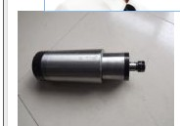

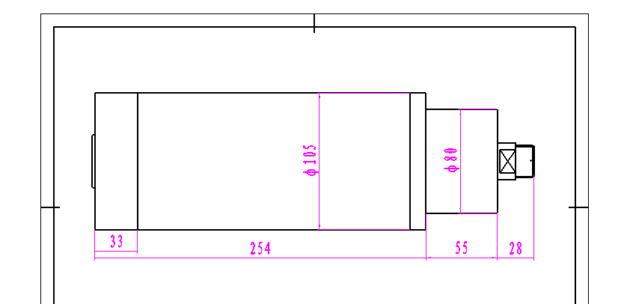
2.2kw Spindle Motor (Permanent Power):
Brand name: Haina
Spindle type: HNZ-105D/2.2
Function: used in metal carving ,and engraving
Rev(r/min): 12000-24000
Power(kw): 2.2
Voltage(v): 220
Current(A): 6.5
Frequency(HZ): 400-800
Cool: cooled by water
Lubricate: grease
Bearing type: 2*7005CP4 2*7004CP4
Repair time: bearing(half year), spindle(one year)
Collet(mm): ER20
Diameter(mm): 105
EXW：USD647

3.0kw Spindle Motor
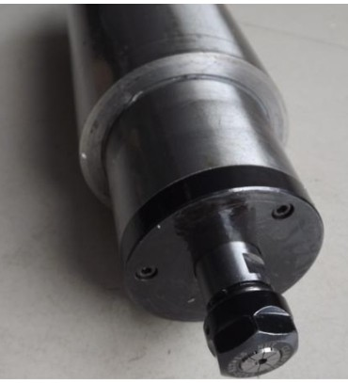

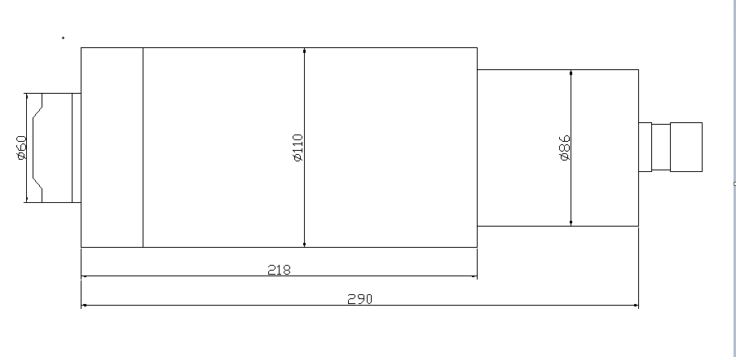
3.0kw Spindle Motor (Permanent Power):
Brand name: Haina
Spindle type: HNZ-110D/3.0
Function: used in metal carving ,and engraving
Rev(r/min): 12000-24000
Power(kw): 3.0
Voltage(v): 380
Current(A): 10
Frequency(HZ): 400-800
Cool: cooled by water
Lubricate: grease
Bearing type: 2*7005CP4 2*7003CP4
Repair time: bearing(half year), spindle(one year)
Collet(mm): ER25
Diameter(mm): 110
EXW：USD761
5.5kw Spindle Motor
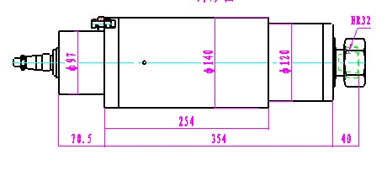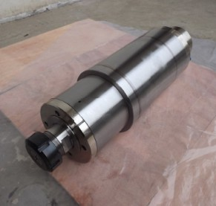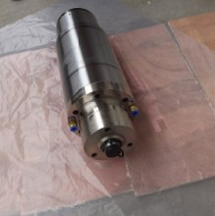

5.5kw Spindle Motor (Permanent Power):
Brand name: Haina
Spindle type: HNZ-140D/5.5
Function: used in metal carving ,and engraving
Rev(r/min): 3000-16000
Power(kw): 5.5
Voltage(v): 380
Current(A): 15
Frequency(HZ): 800
Cool: cooled by water
Lubricate: grease
Bearing type: 4*7010CP4 2*7008CP4
Repair time: bearing(half year), spindle(one year)
Collet(mm): ER32
Diameter(mm): 140
EXW：USD1163

SPINDLE MOTOR（COOLED BY AIR）
1.5kw Spindle Motor
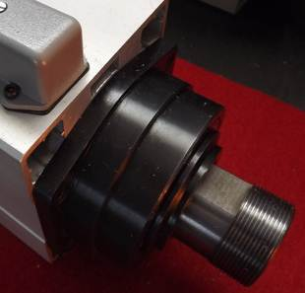
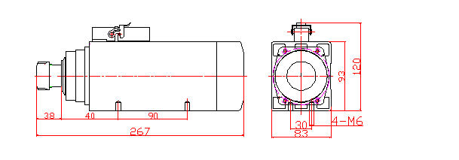 1.5kw Spindle Motor：
Brand name: Haina
Spindle type: HNZ-1.5
Function: used in wood carving machine
Rev(r/min): 18000-24000
Power(kw): 1.5
Voltage(v): 220
Current(A): 5.5
Frequency(HZ): 300
Cool: cooled by air
Lubricate: grease
Torque：0.8Nm
Bearing type: 2*7005CP4 HQ1 1*7002CP4 (Ceramic ball)
Repair time: bearing(half year), spindle(one year)
Weight（kg）：6.5
Collet(mm): ER20
Length (mm): 267
EXW：USD269

2.2kw Spindle Motor
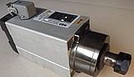
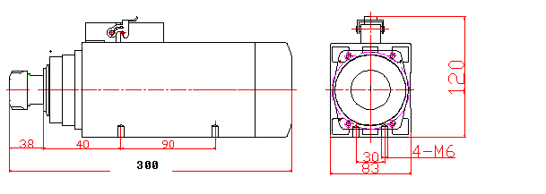
2.2kw Spindle Motor：
Brand name: Haina
Spindle type: HNZ-2.2
Function: used in wood carving machine and engraving
Rev(r/min): 18000-24000
Power(kw): 2.2
Voltage(v): 220
Current(A): 7.8
Frequency(HZ): 300
Torque：1.16Nm
Cool: cooled by air
Lubricate: grease
Bearing type: 2*7005CP4 HQ1 1*7002CP4 (Ceramic ball)
Repair time: bearing(half year), spindle(one year)
Weight（kg）：7.5
Collet(mm): ER20
Length (mm): 297
EXW：USD293

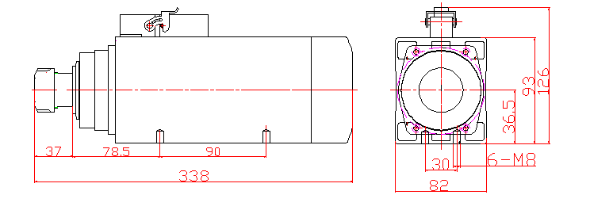
3.7kw Spindle Motor

3.7kw Spindle Motor：
Brand name: Haina
Spindle type: HNZ-3.7
Function: used in wood carving machine and engraving
Rev(r/min): 18000-24000
Power(kw): 3.7
Voltage(v): 380
Current(A): 7.4
Frequency(HZ): 300
Torque：1.96Nm
Cool: cooled by air
Lubricate: grease
Bearing type: 2*7007CP4 2*7002CP4 (Ceramic ball)
Repair time: bearing(half year), spindle(one year)
Weight（kg）：9
Collet(mm): ER25
Length (mm): 338
EXW：USD454

4.5kw Spindle Motor

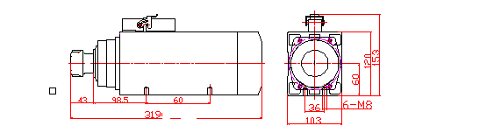

4.5kw Spindle Motor：
Brand name: Haina
Spindle type: HNZ-4.5
Function: used in wood carving machine and engraving
Rev(r/min): 18000-24000
Power(kw): 4.5
Voltage(v): 380
Current(A): 9.0
Frequency(HZ): 300
Torque：2.38Nm
Cool: cooled by air
Lubricate: grease
Bearing type: 2*7008CP4 2*7002CP4 (Ceramic ball)
Repair time: bearing(half year), spindle(one year)
Weight（kg）：11.5
Collet(mm): ER32
Length (mm): 310
EXW：USD583

6.0kw Spindle Motor
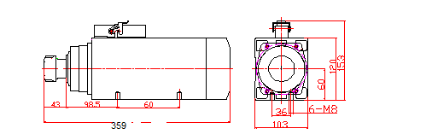
6.0kw Spindle Motor：
Brand name: Haina
Spindle type: HNZ-6.0
Function: used in wood carving machine and engraving
Rev(r/min): 18000
Power(kw): 6.0
Voltage(v): 380
Current(A): 12.0
Frequency(HZ): 300
Torque：3.18Nm
Cool: cooled by air
Lubricate: grease
Bearing type: 2*7008CP4 HQ1 1*7002CP4 (Ceramic ball)
Repair time: bearing(half year), spindle(one year)
Weight（kg）：13.5
Collet(mm): ER32
Length (mm): 350
EXW：USD665

BT30 5.5kw

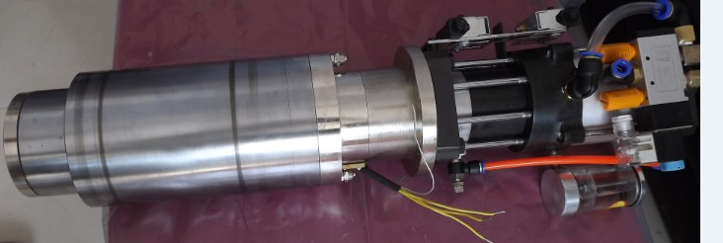
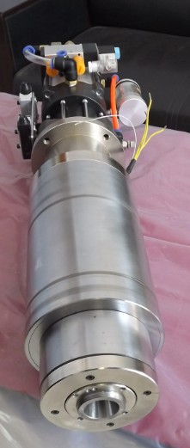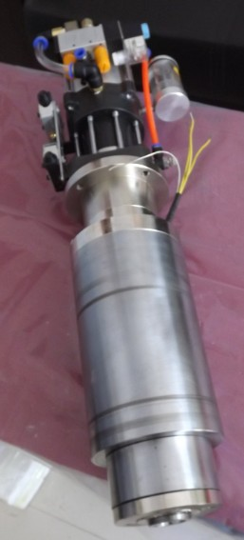
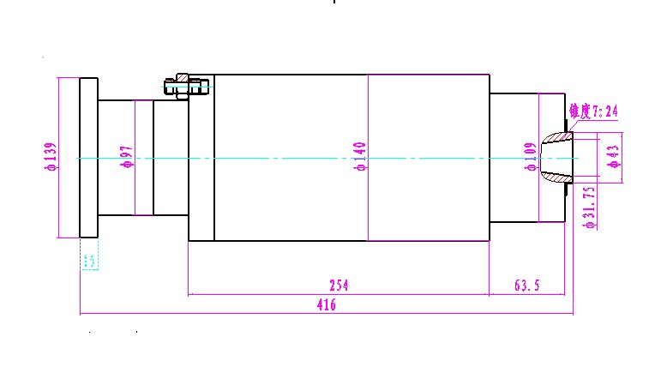
Brand name: Haina
Spindle type: 140-HNZ5.5
Power: 5.5KW
Joint of Nose: BT30
Noise：66db
Voltage: 380v
Shocking:0.5μm
Current: 15A
Diameter:140mm
Length:416mm
Cooling：water cooling
Speed: 3000-16000rpm
Temperature control：18℃
Frenquency: 800Hz
Torque: 3.6N.m-18Nm
Bearings:7010*4 7008*2
Repair time: bearing(half year), spindle(one year)
EXW price :USD2635

CNC PRECISION AUTOMATIC LATHE
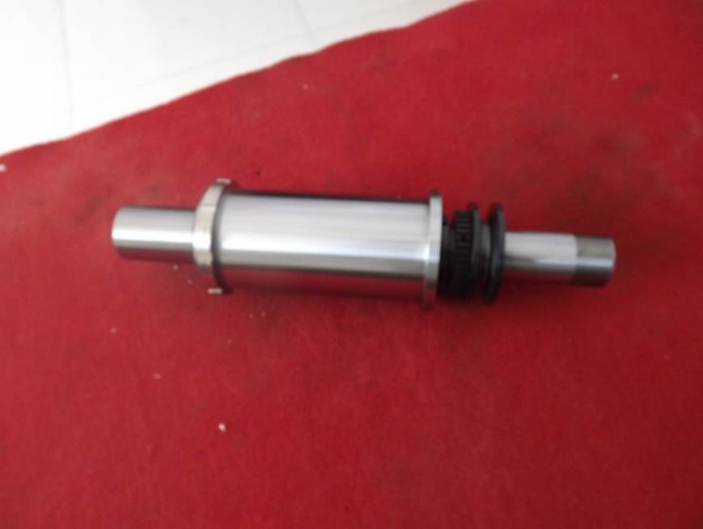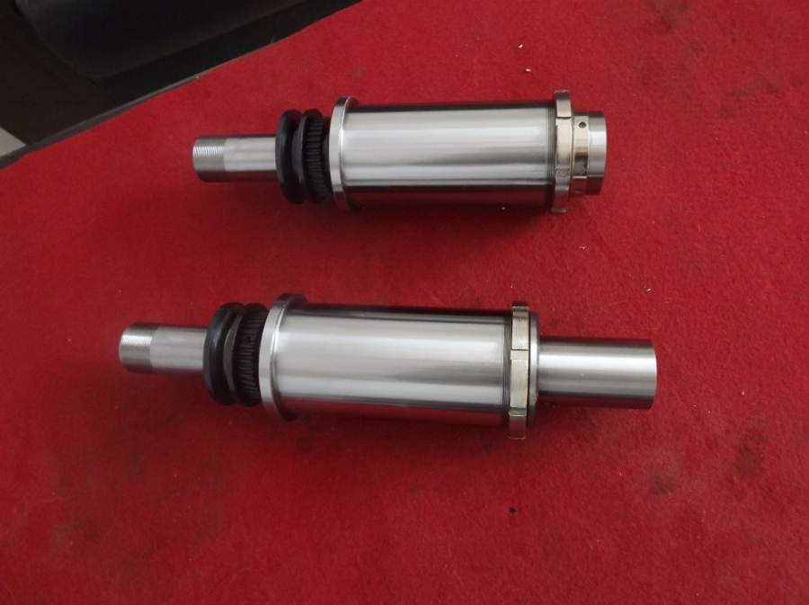
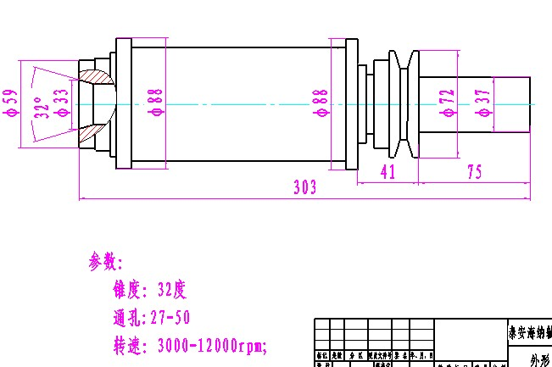
CNC PRECISION AUTOMATIC LATHE：
Brand name: Haina
Spindle type: HNZ-CK0620
Function: used in cnc precision automatic lathe
Rev(r/min): 3000-12000
Repair time: bearing(half year), spindle(one year)
Length (mm): 303mm

ATC ISO 20 1.5KW SPINDLE
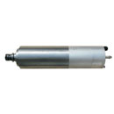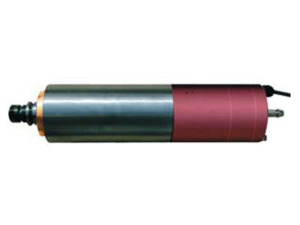
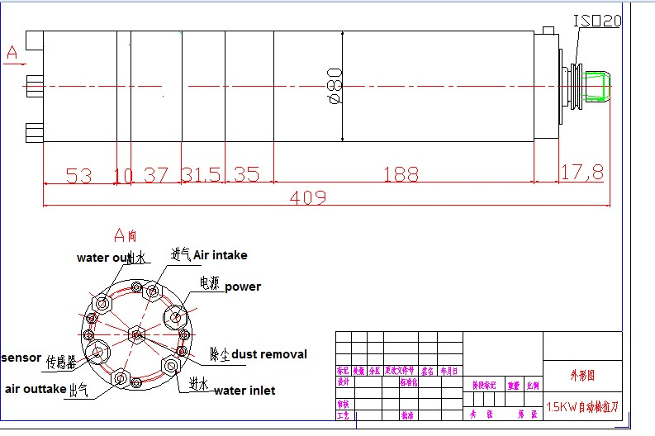
Brand name: Haina
Spindle type: 80-HNZ24Z1.5
Power: 1.5KW
Joint of Nose: ISO 20
Noise：66db
Voltage: 220v
Shocking:1.0μm
Current: 5.4A
Diameter:80mm
Length:409mm
Cooling：Grease
Speed: 24000rpm
Temperature control：22-25℃
Frenquency: 400Hz
Torque: 0.6N.m
Bearings:7006*2 7004*1
Repair time: bearing(half year), spindle(one year)
EXW price:USD1743

Генеральный директор ______________________ Савватеев В.А.
Контактные данные: тел. 914-318-43-57, Skype: savva56

