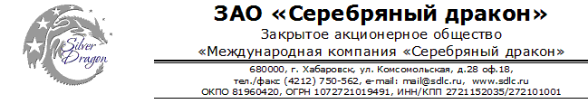

Станок для гибки акрила
Цена DDP Хабаровск 175 000 руб.
Срок поставки в течение 20 дней с момента предоплаты.

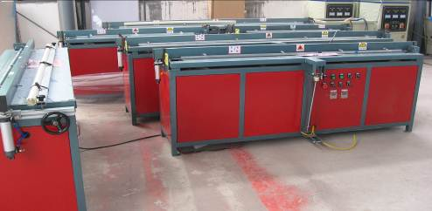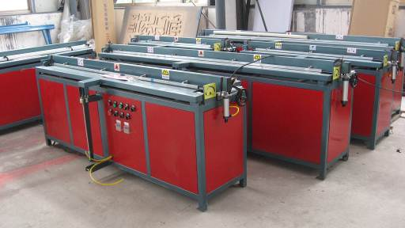
1.Domestic first manufactured-Infrared plating barium heater and unique energy saving heat insulation device make the heating temperature equally ,meantime can make heat radiation upward, save 40% energy than ordinary machine.
2.When bending,the heater can shift and interrupt power supply. To make the material cooling and shaping more rapidly,save more energy,operation more reasonable and humanity.
3.Our special multifunction fixing position and protractor,can make the bending angle adjustble,steerable,accurate and convenient.
4.Automatically water cooling system,can make the machine has the line heating function.
5.The working table is thick stainless steel platform,avoid the acrylic damaging when it is working.
6..The machine with special Double leakage automatic protection function, safety in use.
7.Integration of high strength of frame, stable performance, convenient for transportation and installation.
8.Wide usage: the machine can process acrylic board; ABS board; PVC board; Sunshine board and etc.
9.Automatic bending function.can bend automaticly according to plate requirements to.cool and finalize the design after bending, then flap plate to return.Remove bended workpiece. Fully realized automation.

Technical data:
Model | BZG-600-Z | BZG-1200-Z | BZG-1600-Z | BZG-2400-Z
Power | 1KW | 2KW | 2KW | 3KW
Effective bending width | 600MM | 1220MM | 1600MM | 2400MM
Voltage | 220V 50HZ
Effective bending length | no restrict
Maximum heating temperature | 650 degree
Bending Angle | The 0-179 degree arbitrary adjustable
Bending Type | Acute Angle、Round arc for choice
Each corner bending time | 7-12 seconds
Material thickness | 0mm-8mm
Mould press lever working way | pneumatic
Mould press lever pressure | 0KG-150KG
Mould press lever working speed | 1''-10''/time(adjustable)
Maximum volume of water tank | 30L
Applicable industry | plastic material bending
Sample:
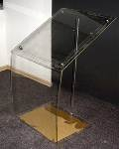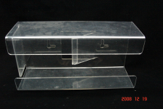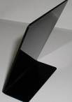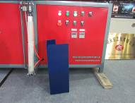

Генеральный директор ______________________ Савватеев В.А.

Контактные данные: тел. 914-318-43-57, Skype: savva56

