Product introduction
- pneumatic making machine brief introduction:
- Through to be printed in English and Chinese characters, graphics content input computer, computer marking software to convert the content to digital control signals, which are transmitted to the controller, the driving the print needle moves according to the designed trajectory in X-Y two dimensional plane ,at the same time print needle in the action of the compressed air under high frequency micro shock motion,resulting in the surface of the workpiece to print out dense lattice composed of concave mark.
Its characteristic is marking standardization, speed, depth, printed by the marking in appearance, durability, it can automatically print serial number and so on, high degree of automation, simple operation, no supplies, can working under bad environment, stable and reliable.
It can print Chinese and English characters, figures, arbitrary graphics, automatic serial number printing, international VIN code printing, time and date printing, bar code printing, printing, print electromagnet circumferential surface adsorption, dot character printing, code printing.
- Print materials: metal materials: steel, alloy steel, copper, bronze, iron, cast iron, aluminum,cast aluminum, aluminum alloy; non-metallic materials: plastics, PVC, wood, paper materials and so on.
- Main characteristic:
Printing material hardness: < HRC60
Printing surfaces: plane, inclined plane, circumference
Print needle impact frequency:250-350/ sec
Repeat print accuracy:0.02mm
Print depth:0.01-2mm ( as materials .)
Print speed : second2-3 characters or the 30-80mm line
Print range : the plane of maximum500 x500mm2
The external communication interface, an external bar code machine, scanner,
Automatic contrast serial number, VIN codes, two-dimensional bar code, prompted repeat
Daily print content file, and can be readily retrieved historic print data
Meet IS09001-9002 quality certification of product identification traceability requirements
Voltage / power:220V50Hz + 10%,about 400W
Air pressure:0.3-0.6MPa
Temperature degree:5-45
Wet: less than or equal to 90%

- B80/B80A Pneumatic tag printers
1、Main index
The print mode: pneumatic needle, automatic printing
Print size:100 x80mm2;200150mm2;300 x200mm2;
Print content: English, digital, trademark logo
Font size: any size, computer editing
Print speed:3-5characters per second
Print depth:0.01-1.5mm
Memory function: automatic order number, a print quantity and content automatic storage
Voltage / power:220V50Hz + 10%,300W
Air pressure:0.3-0.6MPa
Temperature degree:5-45C
Wet: less than or equal 90%
- Main characteristics
B80 series label printer is applicable in a variety of products label print trademarks, technical parameters, date, name of the enterprise and other content, such as stainless steel, copper, aluminum and other metal plate, PVC plastic, paper tickers, leather and other special label s. the print marks is gravure printing, its characteristic is character normative, beautiful, neatly arranged, accurate, formal appearance, high grade. The whole plate deformation , conveniently installation, signs of weathering, abrasion resistant capability is strong, durable and reliable.
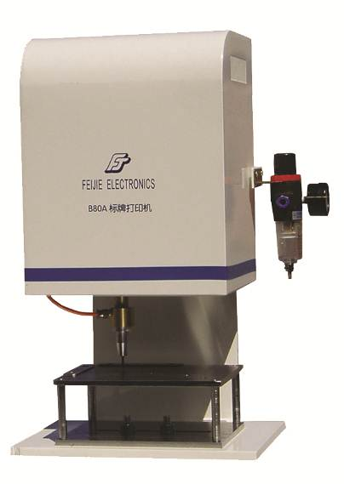
3、Prototype images and typical sample pictures 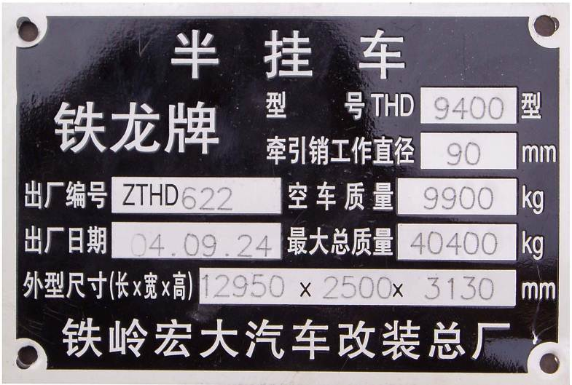

4、Standard and optional configuration
Standard configuration: B80 series label printers, driver software, sign bracket,100 x80mm2;200 150mm2;300 x200mm2 variety of print area is optional.
Optional configuration: computer, pneumatic signage fixture, foot switch, plate automatic feeding device, an air pump.
(B) FJ2000 Portable pneumatic making machine
Printing material hardness: < HRC60
Printing position surface: plane, inclined plane
Print needle impact frequency:250--350/ sec
Repeat print accuracy:0.02mm
Print depth:0.01-2mm ( as materials .)
Print speed : second2-3 characters or the 30-80mm line
Print range : graphic standard100 x20 mm2 /10050mm2
The external communication interface, an external bar code machine, scanner,
Operating system, Window98,2000, XP
Print the serial number, VIN codes, two-dimensional bar code, automatic contrast, prompted repeat
Daily print content file, and can be readily retrieved historic print data
Meet IS09001-9002 quality certification of product identification traceability requirements
Voltage / power:220V50Hz + 10%,about 400W
Air pressure:0.3-0.6MPa
Temperature degree:5-45C
Wet: less than or equal 90%
- Main index
A portable hand-held planar pneumatic marking machine, computer editing, can also be configured to SCM controller, small size, light weight , mobile printing; suitable for large equipment, Heavy element field handheld printing
3、Prototype images and typical sample pictures

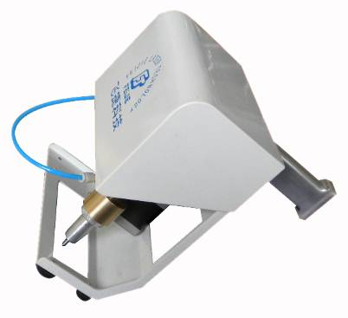
4、mark and optional standard configuration
Standard configuration: Marking software, controller or a single chip microcomputer controller, pneumatic printing head, printing range level standard level standard100x 20/ 100 x50mm2;
Optional configuration: computer, standard cabinets, SCM controller, mobile carts, pneumatic fixture, the foot switch and the electric lifting stand, an air pump.
(C) FJ2200 The electromagnet attached pneumatic making machine
1、Main index
Printing material hardness: < HRC60
Printing position surface: plane, inclined plane
Print needle impact frequency:250--350/ sec
Repeat print accuracy:0.02mm
Print depth:0.01-2mm ( as materials .)
Print speed : second2-3 characters or the 30-80mm line
Print range : graphic standard100 x50 mm2 /15080mm2
The external communication interface, an external bar code machine, scanner
Operating system, Windows982000, XP
Print the serial number, VIN codes, two-dimensional bar code, automatic contrast, prompted repeat
Daily print content file, and can be readily retrieved historic print data
Meet IS09001-9002 quality certification of product identification traceability requirements
Voltage / power:220V50Hz + 10%,about 400W
Air pressure:0.3-0.6MPa
Temperature degree:5-45C
Wet: less than or equal 90%
- Main characteristics
Magnet adsorption type hand plane pneumatic making machine, computer editing, can also be configured to single chip controller, the print head suck on the workpiece surface printing; suitable for large equipment, heavy industry, especially the automobile frame VIN code, ship, automobile chassis, a large valve field print.
- Prototype images and typical sample pictures

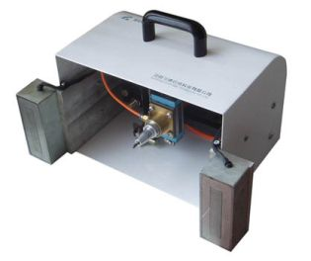

4、Standard and optional configuration
Standard configuration: Marking software, special controller, pneumatic printing head, printing range level standard level standard100x 50/ 150 x80mm2mm2;
Optional configuration: optional magnet or electric permanent magnet two suck way, computer, standard cabinets, dedicated controller, mobile carts, pneumatic fixture, a foot switch, electric lifting stand, an air pump, dust cover.
(D) FJ3000/FJ3000A/ FJ3000B Standard plane pneumatic making machine
- Main index
Printing material hardness: < HRC60
Printing position surface: plane, inclined plane
Print needle impact frequency:250--350/ sec
Repeat print accuracy:0.02mm
Print depth:0.01-2mm ( as materials .)
Print speed : second2-3 characters or the 30-80mm line
Print range : graphic standard100 x80 mm2 maximum of 500 x500mm2
The external communication interface, an external bar code machine, scanner
Operating system, Windows98,2000, XP
Print the serial number, VIN codes, two-dimensional bar code, automatic contrast, prompted repeat
Daily print content file, and can be readily retrieved historic print data
Meet IS09001-9002 quality certification of product identification traceability requirements
Voltage / power:220V50Hz + 10%,about 400W
Air pressure:0.3-0.6MPa
Temperature degree:5-45C
Wet: less than or equal 90%
- Main index
General purpose flat pneumatic marking machine, computer editing, desktop publishing; suitable for metal materials and plastic depth label printing
3 、Prototype images and typical sample picture

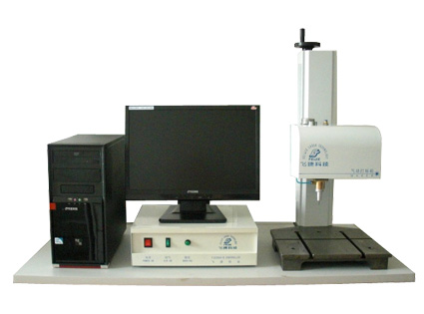
4、Standard and optional configuration
Standard configuration: Marking software, controller, pneumatic printing head, an adjustment bracket, print range for plane standard 100x 80mm2 / 170x 80mm2 / 200x 150/500 x 500mm2mm2maximum;
Optional configuration: computer, standard cabinets, pneumatic fixture, a foot switch, electric lifting bracket, a rotating device, an air pump, dust cover .
(E) FJ5000 Standard rotary + flat pneumatic marking machine
- Main index
Printing material hardness: < HRC60
Printing position surfaces: plane, inclined plane, circumference
Print needle impact frequency:250--350/ sec
Repeat print accuracy:0.02mm
Print depth:0.01-2mm ( as materials .)
Print speed : second2-3 characters or the 30-80mm line
Print range : graphic standard100 x80 mm2 maximum of 500 x500mm2; diameter lower than 10- <250 mm
The external communication interface, an external bar code machine, scanner
Operating system: Windows98,2000, XP
Print the serial number, VIN codes , two-dimensional bar code, automatic contrast, prompted repeat
Daily print content file, and can be readily retrieved historic print data
Meet IS09001-9002 quality certification of product identification traceability requirements
Voltage / power:220V50Hz + 10%,about 400W
Air pressure:0.3-0.6MPa
Temperature degree:5-45C
Wet: less than or equal 90%
- Main characteristics
Universal rotary + plane pneumatic marking machine, computer editing,3D printing switch, desktop publishing ; suitable for metal materials and plastic depth label printing.
- Prototype images and typical sample picture
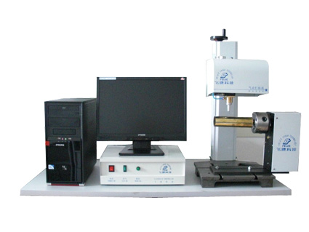

4、Standard and optional configuration
Standard configuration: Marking software, controller, pneumatic printing head, an adjustment bracket,print range for plane standard 100x 80mm2 / 170x 80/200x 150mm2mm2 / max500 x500mm2, circumference; diameter lower than 10-250 mm; FJ5000 archives, domestic parts and components, industrial design;
Optional configuration: computer, standard cabinets, pneumatic fixture, a foot switch, electric lifting bracket, a rotating device, an air pump, dust cover.
(F) FJ8000 Three dimensional multifunctional pneumatic marking machine
- Main index
Printing material hardness: < HRC60
Printing position surfaces: plane, inclined plane, circumference
Print needle impact frequency:250--350/ sec
Repeat print accuracy:0.02mm
Print depth:0.01-2mm ( as materials .)
Print speed : second2-3 characters or the 30-80mm line
Print range : graphic standard100 x80 mm2 maximum of 500 x500mm2; diameter lower than 10- <1500 mm
The external communication interface, an external bar code machine, scanner,
Operating system: Windows98,2000, XP
Print the serial number, VIN codes , two-dimensional bar code, automatic contrast, prompted repeat
Daily print content file, and can be readily retrieved historic print data
Meet IS09001-9002 quality certification of product identification traceability requirements
Voltage / power:220V50Hz + 10%,about 400W
Air pressure:0.3-0.6MPa
Temperature degree:5-45C
Wet: less than or equal 90%
- Main characteristics
Three dimensional multifunctional pneumatic marking machines, there are two dimensional, two dimensional surface, three-dimensional surface, horizontal rotation and other marking mode, multifunctional software supports selection, computer editing,3D printing switch, desktop publishing; suitable for metal materials and plastic depth identification multifunctional printing.
3、Prototype images and typical sample picture

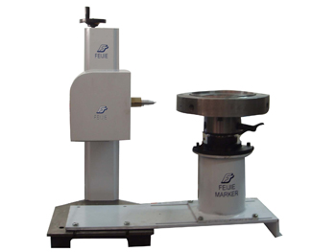
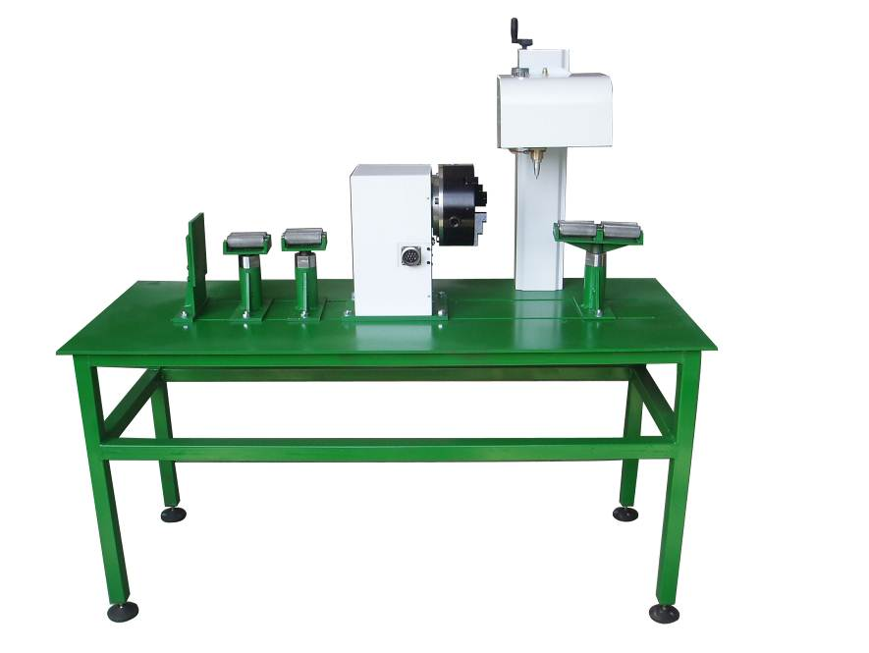
4、Standard and optional configuration
Standard configuration: multifunctional marking software, controller, pneumatic printing head, an adjustment bracket, print range for plane standard 100x 80mm2 / 170x 80/200x 150mm2mm2 / max500 x500mm2, circumference; diameter lower than10, diameter1500 mm;
Optional configuration: computer, standard cabinets, pneumatic fixture, a foot switch, electric lifting stand, rotary device , horizontal large diameter rotary device, an air pump, dust cover.
- Laser marking machine brief introduction
- The principle of laser marking machine ---- is the high energy density of the laser beam under the control of the computer, to illuminate the surface that required marking products,it make the surface of the product moment melting or vaporization,resulting in product surface marking out the required text or pattern identification.
2、Features - laser marking has a permanent solid, exquisite designs, high speed and high efficiency, non contact, high repeat precision, no plate, no pollution, easy to implement and production line synchronization features such as flight print. The markup content can be numbers, letters, Chinese characters, graphics, such as bar code. Is the current international popular most advanced making mode.
3、Application field- in electronic components, hardware tools, sanitary ware, stainless steel appliances, automobile, motorcycle parts, aerospace devices, integrated circuit chip, food beverage tobacco packaging, mobile phone keys, batteries, electronic components, computer accessories and peripherals, electrical products, communication products, medical equipment, watches, jewelry, industrial bearings, wire and cable, costume jewelry, hard alloy, ceramic, silicon, handicrafts, wood, leather, PVC pipe, household appliances, signs and printing surface and other industries in many fields such as graphic and text markup; modern technology is the most advanced, the most widely used way of marking.
4、Advantage of main components such as lasers, Q switch, the scanning mirror, flat field ( F - theta ) lens and a beam expanding lens are from the international advanced technology of well-known companies; matching power supply, control card, a cold water circulating system are selected military reliability design, hardware performance advantages.
Selection of laser marking software, in addition to having usually multiple text input, automatic serial number generation, automatic time, bar code and are respectively set the process parameters; also has support for Core l DRAW, Auto CAD, Photo-shop and other vector graphics call, support table with rotation and translation functions; and the speed of the production line to the flight line marking function, support USB output control card; is both powerful and stable operation of the excellent software.
5、After sale service ---- uphold Feijie consistent enthusiasm sincere, rich projects, rapid response, timely follow-up service advantages, are laser marking machine stable and reliable for customers to work the important safeguard .
F-FP- 10/20W Fiber laser marking machine
- Main index
Beam quality: M2: 1.5
Average output power:5W / 10W / 20W
Maximum line marking speed 7000mm:7000mm / S
Laser wavelength:1064nm
Marking scope:100 x100 mm2
Optional70x 70 mm2/ 175x 175/300 x300 mm2mm2
Laser repetition frequency:20KHz-80KHz
Minimum character height:0.2mm
Marking depth:0.01-0.2mm
Repeatability:0.005mm
Minimum line width:0.01mm
Power requirements: single-phase 220V / 50Hz / 2A
Overall power consumption: < 500W
Cooling system: air cooled
- Main characteristics
Integration structure optical fiber laser, excellent beam quality, air cooled without water, small volume, high efficiency, long life, maintenance free, it is the world's most advanced marking machine at present;it is suitable for electronic components, electrical products, IT industry, auto parts, hardware tools products, precision instruments, gifts of jewelry, and other medical equipment the end product of precision, fine logo printing.
3、Prototype images and typical sample picture

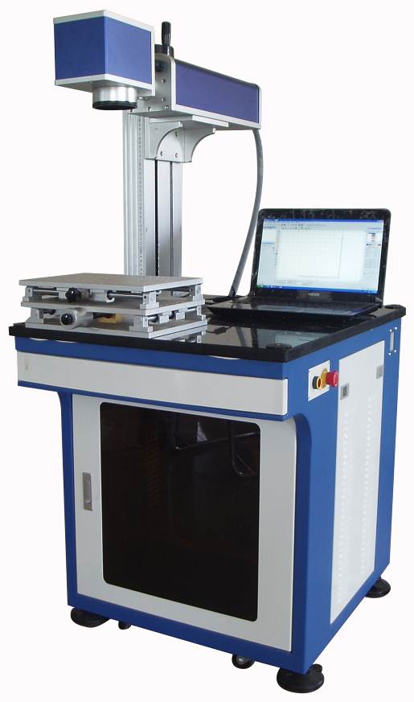
4、Standard and optional configuration
Standard configuration: integration structure optical fiber laser, high speed and high precision optical scanning vibration mirror and the matching power supply; field flattening precision ( F - theta ) lens and a light beam expanding lens system; laser marking software; computer and high speed D / A interface card; model 5W / 10W / 20W corresponding to output power, the core components of imports, industrial design, laser life100000h.
Optional configuration: CNC machine controller, a pedal switch and electric lifting platform, platform, a rotating device, shading system, smoke exhaust system
（B）F-DPS-50/75 Semiconductor pump laser marking machine
- Main index
Max laser power:50W / 75W
Laser wavelength:1064nm
Beam quality: M2 < 3
Laser repetition frequency : less than or equal to 60KHz:
Marking scope:100 x100 mm2
Optional70 x70 mm2/ 175x 175/300 x300 mm2mm2
Marking depth:0.01-0.3mm
Hit marking speed: < 7000mm / S
Minimum line width:0.015mm
Minimum number of characters:0.3mm
Repeat accuracy: + 0.01mm
Users font: all text font font
Tag type: static, dynamic marking marking
Support the print content: bar code, two-dimensional code, the identification image
Overall power consumption :2.5KW
Power requirements: single-phase 220V / / 50Hz
Red positioning system, accurate and convenient
Water, temperature of multiple protection
- Main characteristics
Advanced control technology and intelligent software; high reliability, high stability, high safety; high precision marking quality; can be for a variety of a variety of metals and non-metallic materials for marking, is the application of mature, high performance and price comparison of an excellent making machine .
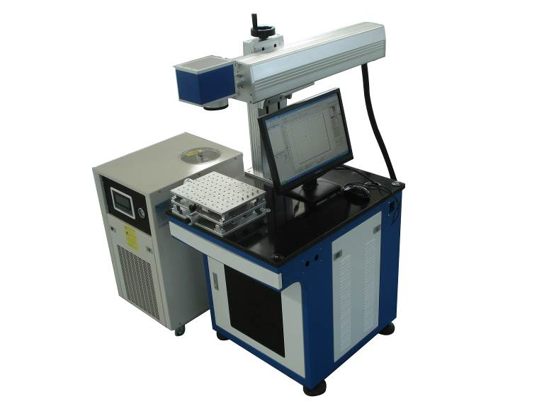
3、Prototype images and typical sample picture

4、Standard and optional configuration

Standard configuration: semiconductor diode pumped head and matching power supply; acousto-optic Q switch and matching power supply; high speed high precision optical scanning vibration mirror and the matching power supply; field flattening precision ( F - theta ) lens and a light beam expanding lens system; laser marking software; computer and high speed D / A interface card; water circulation system; pump head life greater than15000h.
Optional configuration: CNC machine controller, a foot switch, electric lifts, platform, a rotating device, laser system, smoke exhaust system
(C) F-CO₂-10/25/50 CO Laser marking machine
- Main index
Laser: metal packaging sealed RF excited CO2 laser
Average output power:10W / 25W / 60W
Laser wavelength:10.64 M
Laser repetition frequency is less than or equal to 25kHz:
Marking scope:70 x70mm2, optional110 x110mm2,175 x175mm2
The biggest hit marking speed:7000mm / S
Minimum line width:0.1mm
Minimum character high:0.3mm
Cooling way: air / water
The complete machine power supply:500W / 1.2KW AC220V50Hz
2、Main characteristics

CO2laser marking machine is an integration of advanced laser galvanometer marking technology, imports of RF excited sealed-off CO2 laser in one, suitable for most non metal material marking, such as paper packaging, plastic products, paper, leather cloth, glass ceramics, resin plastic, wood products, such as wider use of PCB plate garment accessories , leather, food and beverage packaging, electronics, handicrafts processing, glass and stone processing and other fields of graphics and text marking.
3、Prototype images and typical sample picture
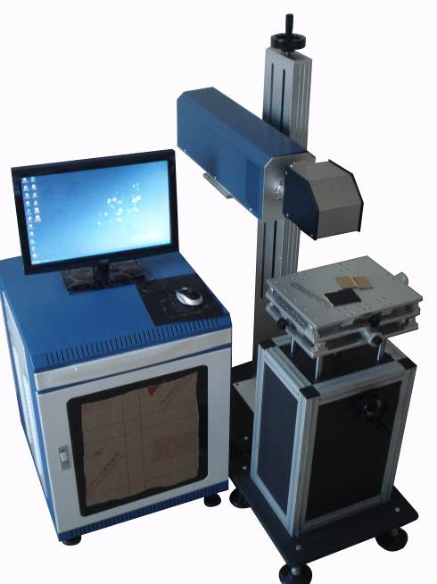
4、Standard and optional configuration
Standard configuration : integration of structural CO2 laser, high speed and high precision optical scanning vibration mirror and the matching power supply; field flattening precision ( F - theta ) lens and a light beam expanding lens system; laser marking software; computer and high speed D / A interface card;

Optional configuration: machine, CNC machine controller, a pedal switch and electric lifting platform, platform, a rotating device, shading system, smoke exhaust system .

HEILONGJIANG XINDAZU LASER EQUIPMENT CO.,LTD

